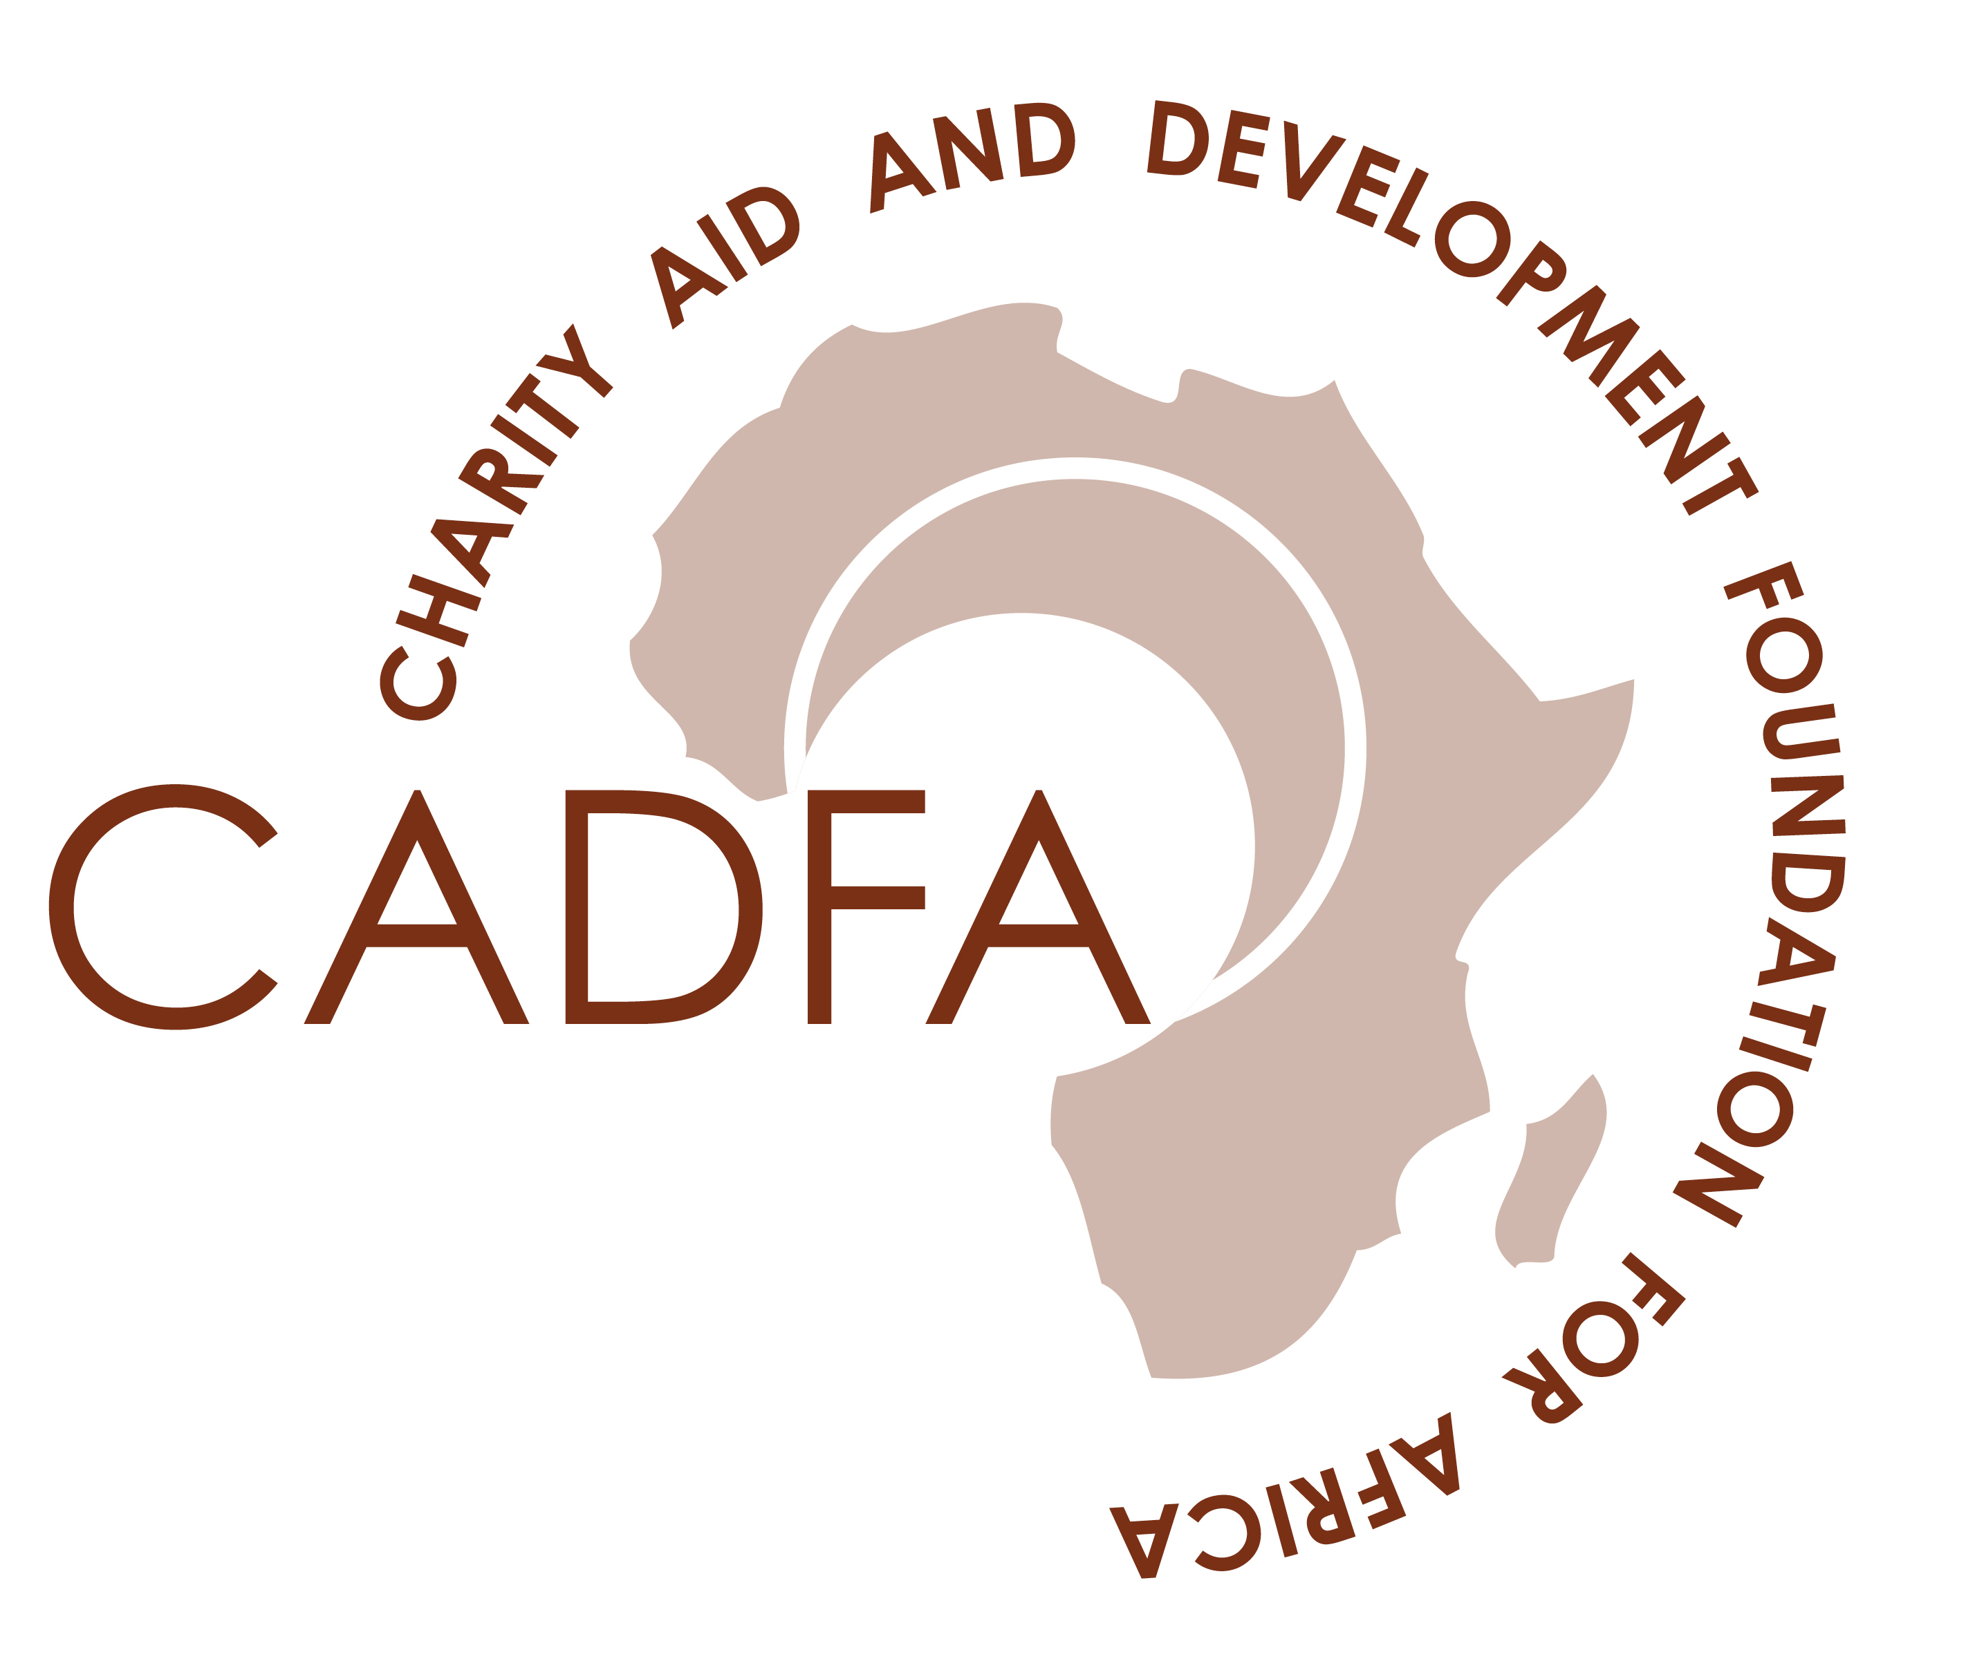

DEMONSTRATING SOCIAL IMPACT IN NIGERIA: STATE OF THE SECTOR RESEARCH.

Background:

No doubt, corporate organisations and international non-government organisations in Nigeria have spent several billions of Naira (Nigerian currency) in attempting to reduce poverty and deliver better standard of living for the disadvantaged people and communities in Nigeria. Anecdotal evidence would suggest that things do not appear to be getting better as the level of poverty and marginalization appear to be increasing in the country. This calls for an investigation into the value that Social Investment has created in Nigeria, at least, in the last ten years. As a matter of course, whether you are a corporate organisation or company investing in the community or a not-for-profit delivering benefits to a particular group in society, demonstrating your social impact (the significant and lasting change that occurs as a result of your work) to a range of internal and external stakeholders has become critical to being a responsible and accountable organisation. This exercise is further necessitated by the increased pressure on resources and the need to demonstrate value for money (vfm) in Africa as the global economy continues to shrink leaving less space for financial recklessness. The above have made it imperative for an independent analysis of the effectiveness of social investment in Nigeria.

What do we want to achieve?

1. We want to do a mapping of Social Investors in Nigeria Corporate organisations, Foundations, Bilateral Organisations such as USAID, USADF, DFID, International NGOs, Multilateral Agencies such as UNDP, World Bank and the value of the Social Investment in Nigeria in the last 10 years.

2. We want to do a mapping of the recipient organisations, NGOs and Community-based organisations in Nigeria and the value that Social Investment has delivered within the last 10 years.

3. We want to investigate whether there has been any coherence in the way the donor organisations give grants to organisations and whether there has been convergence in the expectation of the donors and the recipients.

4. We would like to do a comprehensive baseline research about the state of the sector in Nigeria.

4. We also want showcase some of the success stories and learn lessons on the factors that engender such results.

5. We would also be investigating the causes of “failed” investments and what could have been done otherwise.

6. We are keen to understand the kind of support that donor organisations and recipient organisations would welcome in other to deliver better value for money and enhance effective service delivery for charities in Nigeria.

7. Overall, we want to assist organisations demonstrate their social and economic impact through research, evaluation, training and development programmes specifically tailored made for the Nigerian environment.

Suggested Methodology:

1. Mapping exercise: We want to create a map of Nigeria and identify who is doing what across the country. This will be using various tools such as from the Corporate Affairs Commission (CAC), local intelligence, newspaper call, desktop research, etc.

2. We want to send out Questionnaires to be designed to hear from Donors and recipient organisations about the impact of social investment and the value that has been delivered to beneficiaries in the last 10 years. This will also be the baseline research for the state of the sector in Nigeria. We also would use the tool to know about other issues that we want to investigate.

3. We would carry out structured interviews and also invite organisations to send us their success stories as well as documented materials or case studies for the purpose of sharing those stories to a wider audience.

Output:

1. A document with the suggested title: demonstrating the impact of social investment in Nigeria.

2. Understanding the needs of Donors and donor recipient organisations in Nigeria.

3. A dissemination and validation Conference in Nigeria in the year 2012.

4. Official Launch of our infrastructure charity – Charity Aid and Development Foundation (CADFA) in Nigeria.

